**Montclair State University**

2017

**TreeLOG**

**Tree Map Mobile Application**

**PUMA**

Contents

[1. Description of the problem and social impact (draft) 3](#_Toc480589181)

[2. Credits (draft) 5](#_Toc480589182)

[3. Target Users and audience (draft) 5](#_Toc480589183)

[4. Competitive solutions and the deficiencies of those solutions (draft) 6](#_Toc480589184)

[5. Solution for the TreeLOG application 13](#_Toc480589185)

[6. TODO: Describe the feedback that you got on your initial working prototype: how many participants you had and their demographic characteristics (but don’t include personally identifying information). Summarize the problems you discovered and describe what you changed in your final prototype to address those problems. Feedback 16](#_Toc480589186)

[7. Open issues 16](#_Toc480589187)

[8. Future of the project 17](#_Toc480589188)

[9. Achievement in CfC 2017 (draft) 18](#_Toc480589189)

[10. References (draft) 19](#_Toc480589190)

1. Description of the Problem and Social Impact

The initial idea for the TreeLOG project came from a desire to participate in a competition for techies, as well as a need for a group project topic in our Mobile Computing class. Thus, we started to work with Sustainable Camden County and to participate in the Sustainable Jersey, Coding for Community Competition (CfC 2017). The objective of this competition is to work with a town in New Jersey to collaboratively build a sustainable solution to a challenging local problem, and make a real impact on real issues. Every participant or group of participants had to choose a project from the list available on the website for [CfC 2017](http://cfc.sustainablejersey.com/). Our team PUMA decided to create a mobile application to help map trees in all 21 neighborhoods of Camden City and chose the name TreeLOG for this future mobile application.

Trees are essential to life, providing significant aesthetic, environmental, and ecological benefits. Yet trees can fall or shed branches, potentially injuring property or even people. If you have trees in a landscape, or simply walk or work in public spaces with trees, it’s important to be on the lookout for potential hazards. Currently, volunteers in Camden, carry physical paper spreadsheets to catalogue a tree's location, health, general size, type, potential hazards, etc. Some of that info is then manually inputted to a spreadsheet that is then converted and uploaded to a Google Map. To improve the quality of the city of Camden’s street tree inventory, a more efficient way to survey and get baseline data on street trees would better manage risk and the health and growth of its canopy. Crowd sourcing capabilities are also needed.

The main purpose for having an inventory of the city’s trees is to get grants that the city can use to replant certain areas and neighborhoods. The city should have a coverage of 20% with trees, but currently only has 8-9% coverage.

A tree inventory can be created with different goals in mind for a community. It can be used to determine if a community needs to implement an urban forestry program[[1]](#endnote-1), to prioritize tree maintenance needs, to plan for the community's future, and to provide a basis for the implementation of a management plan.

There are four main types of tree inventories: the specific problem inventory, the partial inventory, the complete inventory, and the cover type inventory. A specific problem inventory gathers data on one problem in particular, such as the effects of a disease. A partial inventory uses sampling where only a subset of the trees in the community are observed to draw inferences on the rest of the tree population. A complete inventory collects data from all the trees in a population and a cover type survey is a survey in which information is gathered regarding the coverage of trees, involving aerial photography and GIS systems[[2]](#endnote-2).

Given the requirements of the tasks set by the municipality of Camden, TreeLOG’s survey will be a complete inventory.

1. Credits

|  |  |
| --- | --- |
| Position/Title  (Alphabetical order of the team members by First name) | First Name and Last Name  (Equal contribution) |
| Moaath Alrajab | Instructor |
| **Members of the PUMA team** | |
| Eliezer Epstein | Classes and methods to work with Google Map and coordinates, related UI |
| Elion Limanaj | DB DAO's, user Auth, Auth related UI, location detection |
| Inga Gaidukova | UI, classes and methods for UI to DB integration |
| Supriya Karambe | Classes and methods to work with Photos, related UI |
| Zahid Aziz | DB DAO's, user Auth, Auth related UI |

1. Target Users and Audience

Inventories like this are generally filled out by student groups and volunteers, contracted to urban forestry consultants, or by municipal urban foresters using handwritten methods, software, templates, smartphones or PDAs.

Initially it was assumed that this project’s audience would be volunteers from Sustainable Camden County Municipality, who are mapping trees. Considering studies conducted since then, it has been determined that the potential audience might expand to include volunteers from organizations that maintain an inventory of parks, city streets, etc., as does the New York City Department of Parks & Recreations.

The application was created for users of devices with the Android platform.

1. Competitive Solutions and the Deficiencies of those Solutions

Initial data for searching competitive applications:

* Keywords: tree inventory, tree inventory app, tree hazard
* Rating: all ratings
* Price: paid and free (listed below are the free applications that were installed for testing, paid apps were evaluated from the point of view of the presented accompanied promotional description)
* Promotion: Pay-Per-Click campaign (PPC, means that an application was found in the paid section and has financial support for distribution) or General catalog
* **Competitive applications which can be found in the App Store**

|  |  |
| --- | --- |
| Application screen | Description |
| TreeIDUSA.jpg | * Name: Tree ID USA * Rating: 4 out of 5 * Price: $4.99 * Promotion: PPC campaign |
| **Pros:**   * Nice design, allows users to build own plots with trees and bushes * Well supported * Tree recognition implemented using step-by-step instructions |
| **Cons:**   * Paid * More concentrated on tree recognition than on inventory * Built for iOS only |
| ArborPlus.jpg | * Name: ArborPlus * Rating: 4 out of 5 * Price: Free * Promotion: General * http://www.arborplus.com |
| **Pros:**   * Free * Has treatment recommendations and future alerts * Uses a cloud platform * Saving battery features * Well supported * Has start tour * Uses GPS technology |
| **Cons:**   * Built for iOS only * For companies only (but has backend on your own subdomain) * More concentrated on collecting data for tree purchases than on inventory |
| TreeRisk.jpg | * Name: Tree Risk Assessment * Rating: 4 of 5 * Price: Free * Promotion: General * http://texasforestinfo.tamu.edu/ |
| **Pros:**   * Connected to GIS (in description) * Can make exports to external files * Related to inventory (pre- and post storm assessments) |
| **Cons:**   * Probably not supported (last modified 2014) * Build for iOS only * Questionable usability on the initial screens, hard to understand how to navigate |
| msues.jpg | * Name: MSUES TreeMetrics * Rating: 4 of 5 * Price: Free * Promotion: General   http://fwrc.msstate.edu/ |
| **Pros:**   * Easy start to use * Integrates several established standards, such as UFORE codes (tree species list), etc * Export to CVS |
| **Cons:**   * For knowledgeable users (absolutly not obvious second step and others * Doesn't decode the street address * Based on plot definition, not tree description, which can lead to not including street trees * Build for iOS only |

* **Competitive applications which could be found in Google Play**

|  |  |
| --- | --- |
| Application screen | Description |
| Screenshot_20170421-221019.png | * Name: Arborjet * Rating: 3 of 5 * Price: Free * Promotion: General |
| **Pros:**   * No inventory application |
| **Cons:**   * Not all buttons work on the main menu * My inventory doesn't work * The application mainly works as a portal for a chemical solution for tree health |
| Screenshot_20170421-221041.png | * Name: WCA Mobile V2 * Rating: 4.7 of 5 * Price: Free   Promotion: General |
| **Pros:** |
| **Cons:**  **Asked for managing phone calls, after denying could not configure the installation process.** |
| Screenshot_20170421-221055.png | * Name: Virginia Tech Tree ID * Rating: 3.7 of 5 * Price: Free * Promotion: General * http://dendro.cnre.vt.edu/ |
| **Pros:**   * Nice design * Step by step tree recognition * Provides option for installation (database contains photos of all Northern American trees) |
| **Cons:**   * Build for Android only * Database of picture takes a lot of space on Smartphone |

* **Distributing the tree inventory applications websites that were found by the results of Pay-Per-Click advertisement campaigns(Google Adwords)**

Why is Pay-Per-Click a source for tree inventory applications?

Figure 1, *Ranges for search volumes for keyword "tree inventory app"*, shows numbers relative to the demand for the keyword, its frequency, the cost per click. The explanation of the Figure 1 is below.

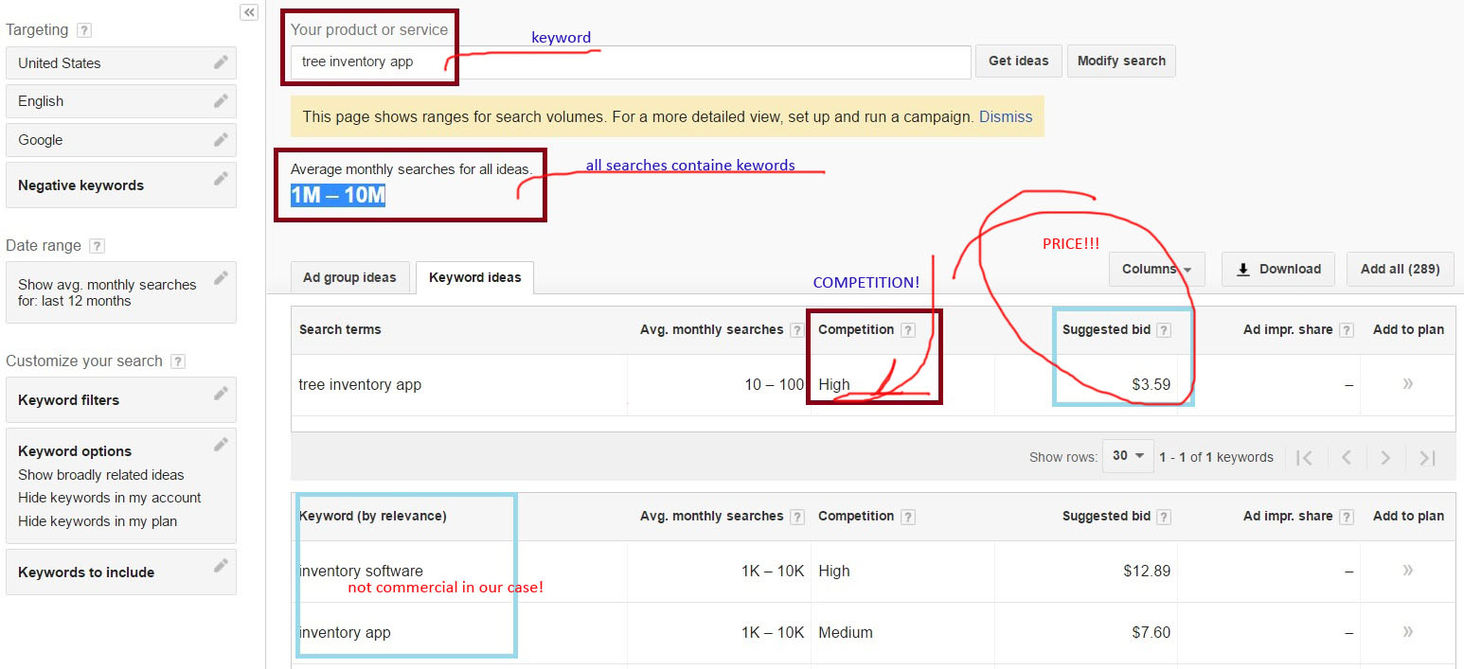

*Figure 1.* *Ranges for search volumes for keyword "tree inventory app"*

On the screenshot in Figure 1, the field "Average monthly searches for all ides" indicates how many times the keyword "tree inventory app" was included in various combinations for Google Search Engine. This field also shows that it was around from 1 to 10 millions times. If we take into the account the statistical conversion of the impressions (number of people who see your PPC advertisment) into the visitors, and this is 10% of the all requests, and the visitors to possible customers, up to 2%, we get after computing about 2,000 times per site per month for all possible combinations of the keyword. Google gives statistics, see the Figure 1, that a specific word has visitors in the range of 10 to 100 per month. The presence of a rather high price (it is a hight price per click!) proves the existence of CTR (click-through rate - is the ratio of users who click on a specific link to the number of total users who can view a page, email, or advertisement, which calculates by Google Adwords), which means that the ratio of clickability to impressions is greater than zero, which proves that there is a demand for this type of product or service. And from our overview Google Play store choice of applications available is anadequate to the demand.

Only one advertisment were found on a special placment (most expensive, above organic search results) to explore.

Figure 2, TreePlotter application overview, shows some preview of mobile application.

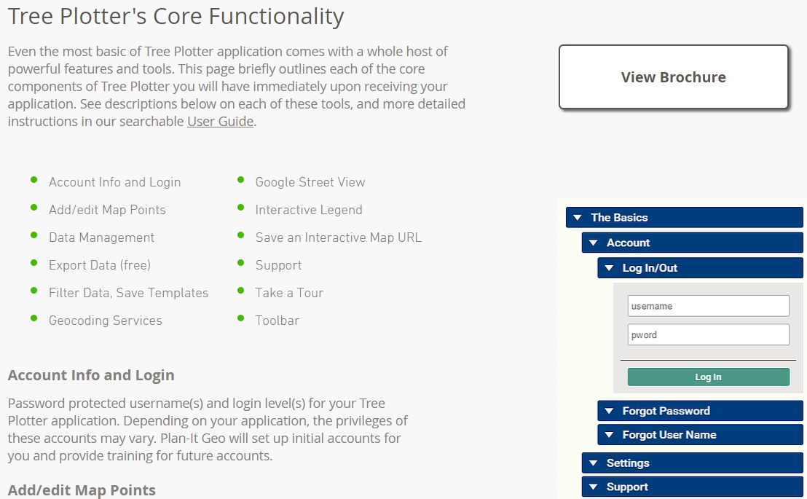

*Figure 2. TreePlotter application overview the only one page.*

* Name: Tree Plotter
* Rating: Not available
* Price: Extremely high (>1250 of basic configuration)
* Promotion: PPC

Pros and Cons are not available for exploring.

* **No distributing the tree inventory applications websites that were found by the results of Organic search**
* **No supporting active pages from Social Media were found (Facebook)**

1. Solution for the TreeLOG application

**5.a Overview of the solution draft**

**Functionality at the initial phase**

According to a project description, a virtual map and mobile application should include the functionalities listed in the below table. In order to increase usability we have decided to include more useful functions.

|  |  |  |
| --- | --- | --- |
| **Function** | **Action** | **Benefit (in compare with current way to process data)** |
| Track GPS location of the tree | Will mark the coordinates of the tree and save to the database | Will automatically save GPS coordinates of the tree instead of writing it in a regular spreadsheet. Will save time in more usable way. |
| Identifying type of the tree | Will use special algorithm build in the mobile application for comparing a photo of the tree leaf to the existing database of all North America trees | Will help to identify a particular type or subtype of a tree automatically instead of relying on a volunteer's knowledge. Will help to avoid mistakes during identifying. A lot of the trees are not identified at all. |
| Photo uploading capabilities | Will use phone's camera to make picture in the application interface with option to save in the database | Functionality was not implemented. Pictures of the trees were not taken. |
| Identify hazards | Will use preset data for usability and identifying a level of the hazard for future actions. | Currently, volunteers make notes in a spreadsheet. Will help to create a sequence of actions and preventive measures |
| Storing all tree related data in database | All data will be saved in a database | Currently all data saved in spreadsheets and paper documents |
| Login options (regular, facebook, google+) | Will allow to use the application | No application in use |
| Administrator of the application | Will allow to customize the application forms | No application in use |

**Functionality at the final phase**

|  |  |  |
| --- | --- | --- |
| **Function** | **Implemented** | **Description** |
| Track GPS location of the tree | Done | Works in different locations |
| Identifying type of the tree | Not implemented | Was not implemented because of limited time and resources. This functionality left on the TODO list. |
| Photo uploading capabilities | Done | Working properly on uploading one photo as well as on uploading many photos at once. Also the program has making photo capabilities. |
| Identify hazards | Done | TreeLOG uses preset data for users convenience and making notes |
| Storing all tree related data in database | Done | The application uses Firebase (real-time cloud database) technology for storing data |
| Login options (regular, facebook, google+) | Done (regular, google) | Facebook authentication not implemented yet. This functionality left on the TODO list. |
| Administrator of the application | Not implemented | Unresolved question about hosting with the client |

5.b TODO Screens of our application with description

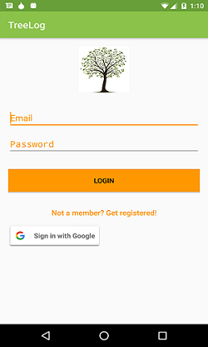 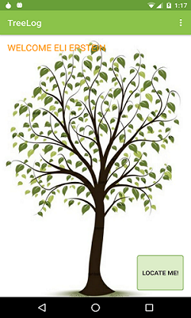 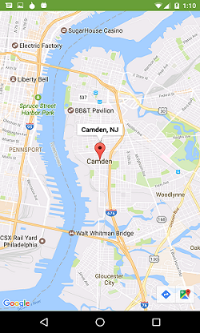

Login Page

Allows the user to login using email and password or using a Google account. Authentication is performed by FirebaseUI.

Map Page

Map view of Camden, prior to new entries being added.

Welcome Page

Displayed when a user logs in or is still logged in from a previous session. Allows the user to navigate to the map (of all trees or of the user’s current location with any trees in a five-block area), to navigate to the tree inventory, or to create a new tree entry.

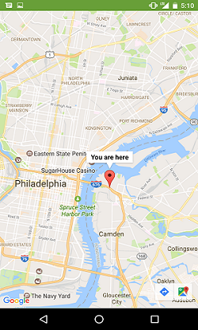 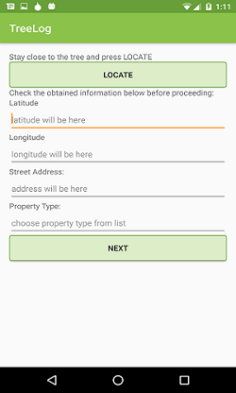 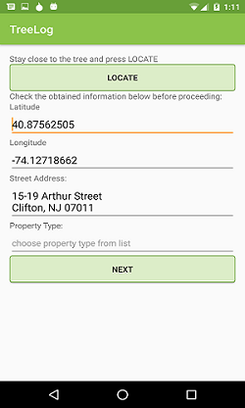

New Tree Page (continued)

When “LOCATE” is clicked it automatically fills out the fields for latitude, longitude, and the resulting street address.

Map Page

Map view of the user’s location (in this case while in Camden – zoomed out).

New Tree Page

Start of the form to add a new entry to the database.

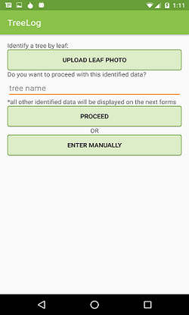 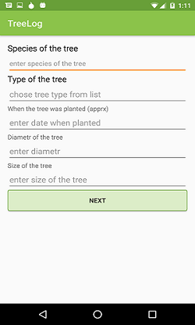 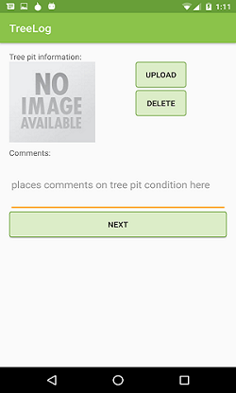

New Tree (continued)

Options to identity a tree by leaf photo and automatically fill out the next list(not-implemented) or enter the data manually.

New Tree (continued)

Option to upload a picture of the tree pit (the area provided for the tree to grow) along with writing a comment about the tree pit condition.

New Tree (continued)

Enter various identifying information regarding the tree, such as: species, type, approximate planting date, and the diameter and size of the tree.

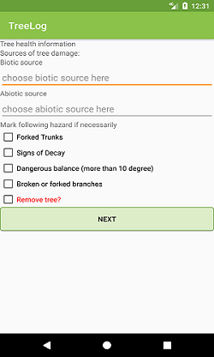 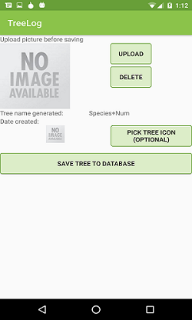 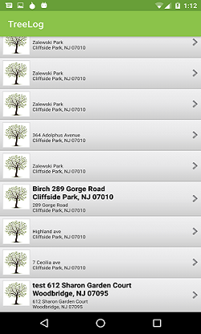

Tree List

Inventory of all trees previously added to the database with address information.

New Tree (continued)

Additional tree health information to enter as needed, including the biotic (i.e., living, like insects or fungi) and abiotic (i.e., non-living, like weather or construction) sources of tree damage.

New Tree (continued)

Option to upload a photo and choose an icon for the tree the user is about to save to the database.

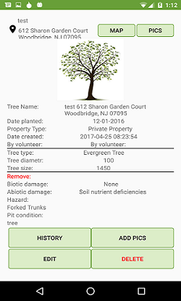

Tree History

Shows tree information, including location, entry creation date, tree type and health.

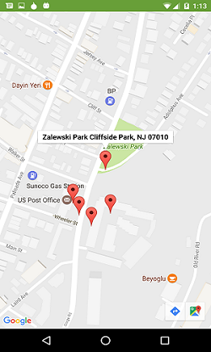

Tree History (map view)

Map view from the tree history page showing the tree’s GPS coordinates and any nearby trees.

5.c. TODO Transition diagram

5.d. TODO: tutorial/help/ for the learners

1. Feedback

Our feedback plan was conducted with five participants, each one was assigned a specific set of tasks to test out different functions within the app. The tasks assigned to each participant, along with demographic data about them and their survey answers are as follows:

**User 1**:

Background Info

28-year old male working in IT/Computer Programming, who uses public transportation, has an Android phone with 7+ years of experience with Android and using similar apps, who does not have a disability.

Tasks

1. Register with email and password
2. Logout
3. Login with email and password
4. Use the app’s “LOCATE ME!” button
5. Navigate to the “Map” page

Survey Response

The user did not have any issues accessing the various modules, but found the app’s location tracking system to be a little inaccurate, commenting: “it showed me being like a block away.”

**User 2**:

Background Info

24-year old female student, who uses public transportation, has an phone, with less than a year’s worth of experience with Android, 4-5 years’ experience using similar apps who does not have a disability.

Tasks

1. Register with Gmail
2. Exit/Logout
3. Login with Gmail
4. Recover password during the login process

Survey Response

The user had difficulty finding the menu from the welcome page, but spoke positively about the color and design, recommends decreasing the number of list pages, commenting: “I feel like I'm click through a million lists, anyway to shorten that?”

**User 3**:

Background Info

27-year old female, who works in IT/Computer Programming, who carpools, has an Apple phone, 0 – 1 years of experience with Android, 0 – 1 years of experience using similar apps, and does not have a disability.

Tasks

1. Navigate to the list of trees in the area and pick a tree
2. Navigate to its map page
3. Navigate to its pics page and view pictures
4. View a tree’s history

Survey Response

This user had difficulty registering and accessing tree history, additionally she had issues uploading pictures and modifying tree history.

**User 4**:

Background Info

29-year old male, works in retail sales, carpools as his primary mode of transportation, has an Apple phone, has 1 – 2 years of experience using Android, 4 – 5 years of experience using similar apps, and does not have any disabilities

Tasks

1. Navigate to the list of trees in the area and pick a tree
2. Add and save a new picture
3. Edit the tree’s content
4. Delete a tree entry
5. Navigate to ‘make a photo’ from ‘Welcome’ page and take a photo

Survey Response

The user had no difficulty navigating to the different sections, but found the location services to be inaccurate, off by several houses and even blocks at times.

**User 5**:

Background Info

18-year old user who preferred not to pick a gender, did not enter info for occupation/mode of transportation, has an Apple phone, 0 – 1 years of experience with Android, 3 – 4 years of experience with similar apps, and does not have a disability.

Tasks

1. Navigate to ‘new tree’
2. Click ‘locate’ to get the user/tree’s current position
3. Fill out new tree info
4. Add a pit image and comment
5. Add tree health information, press ‘next’
6. Upload a picture before saving/pick tree icon, save to database, delete info

Survey Response

The user had issues adding a new tree, but otherwise was able to navigate and register with ease.

**Survey Results**

The following results were gathered and created using Google Forms:

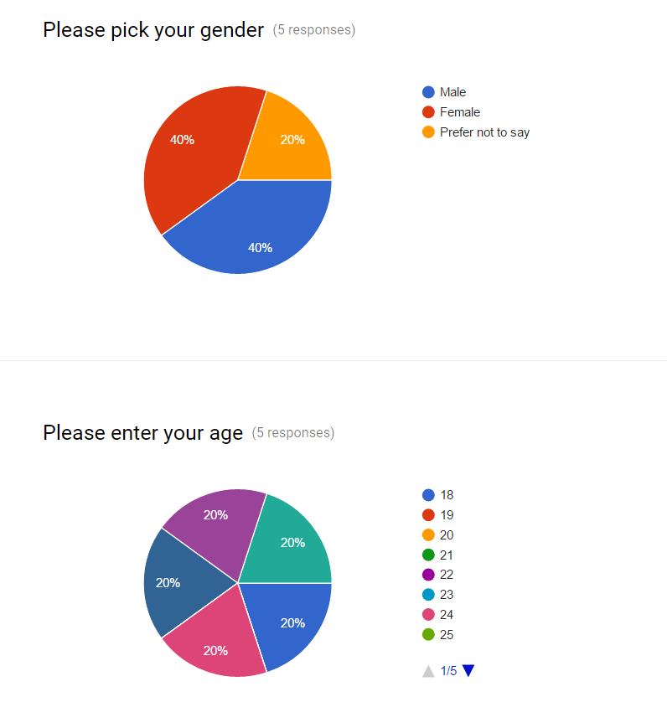

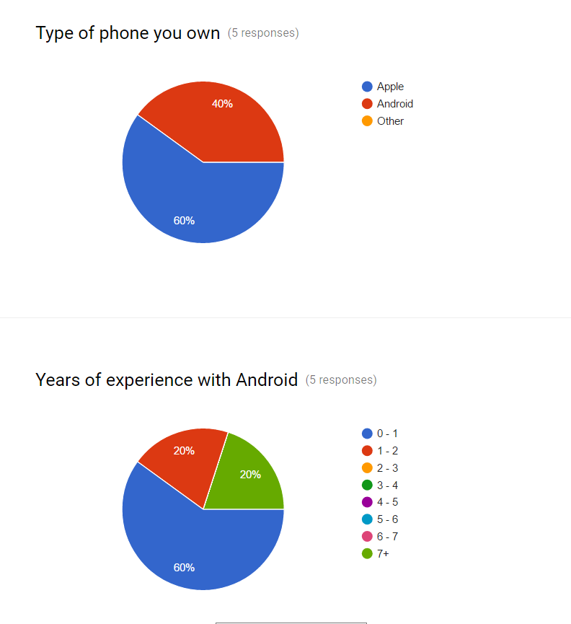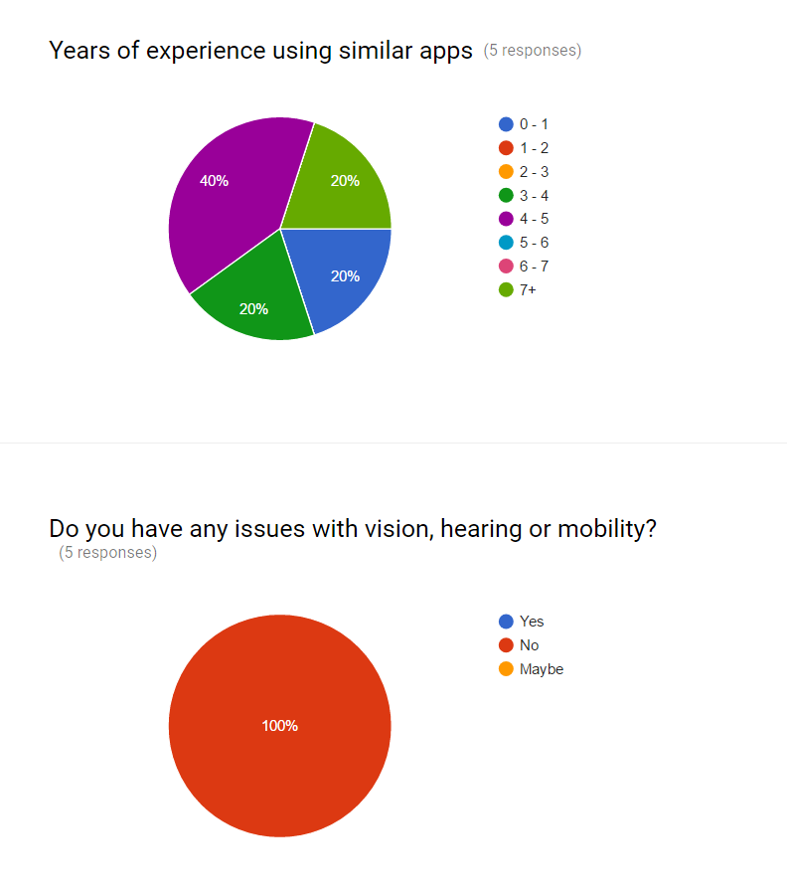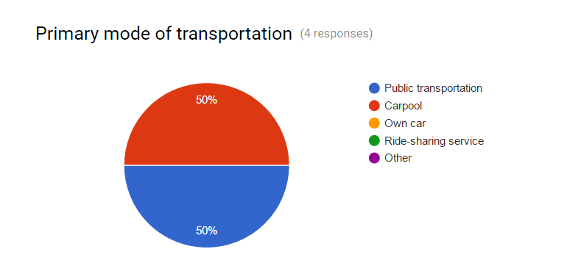

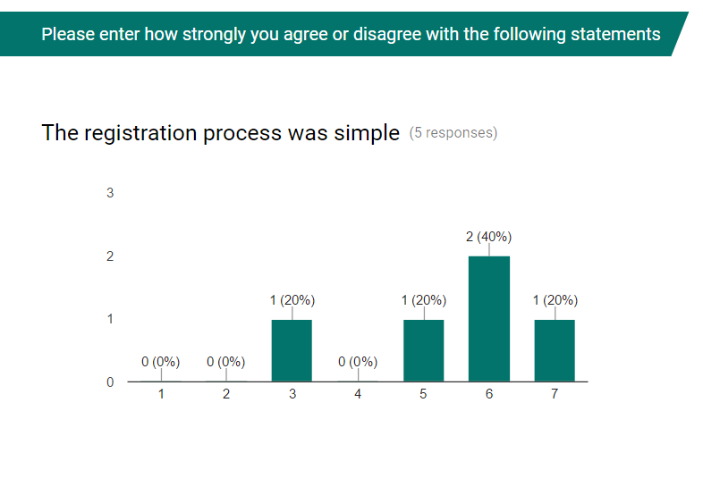

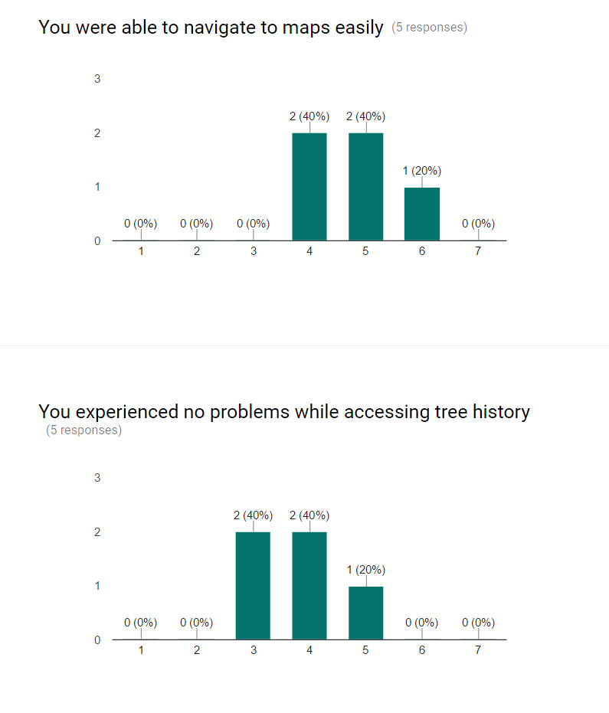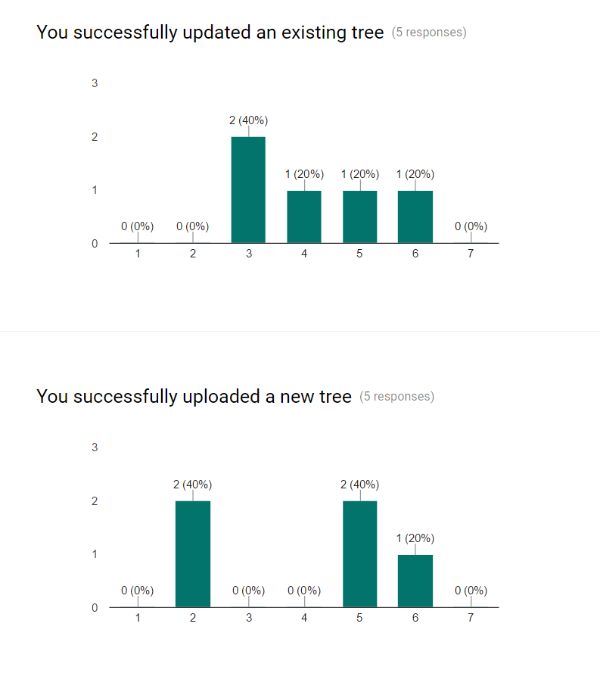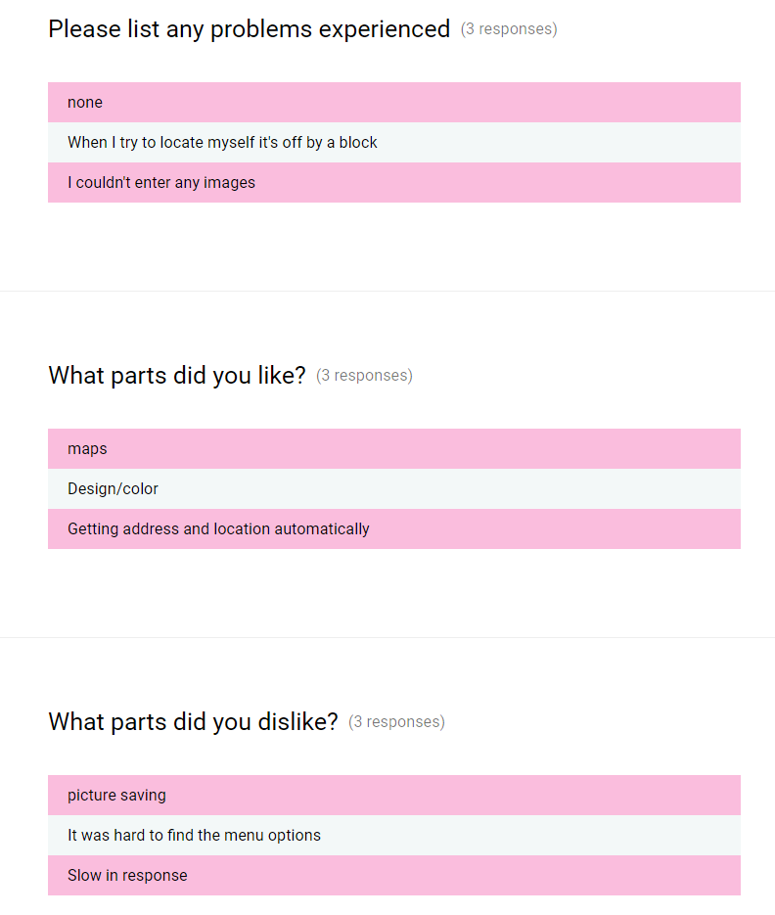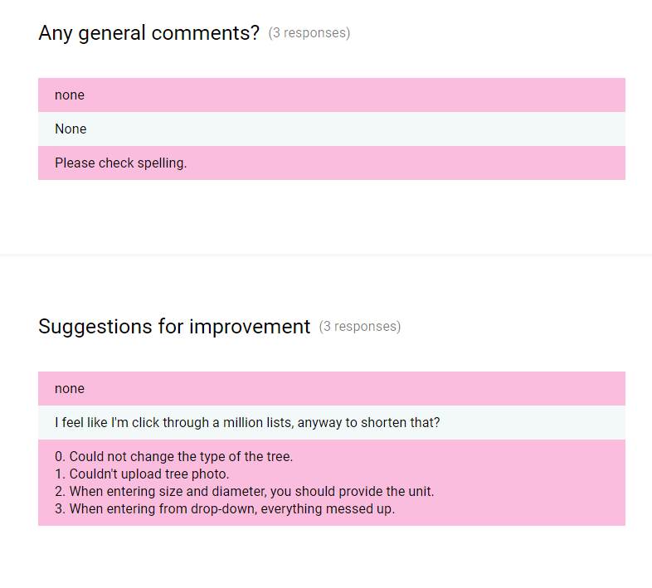

1. Open issues (TODO: draft)

* Validation for tree duplicates
* Location accuracy
* Uploading images

1. Future of the project (draft)

**Current phase**

At the moment, the project must be completed, tested and sent to the customer. All bugs should be fixed. All functionality should be implemented according to the specification.

**Short term perspectives**

TreeLOG application can be used by any organization or person who needs to make tree inventory, such as small town municipalities, departments of parks and recreation, landscape companies and designers, golf clubs, medical centers and rehabilitations, large estates to maintain landscape etc.

TreeLOG application can be improved in several directions, separately or all functionality together listed below:

* User Interface improvement, such as integration with existed database of species in Northern America and step by step tree recognition by using this database.
* User Interface improvement by adding a tutorial how to use the application and glossary.
* Integration with binominal nomenclature (formal system of naming species of living things by giving each a name composed of two parts, both of which use Latin grammatical forms)
* Classification of all types damages (biotic or abiotic) and creation different levels of awareness for treatment suggestions or immediate removal
* Export data to \*.cvs file for client's needs analysis
* Build iOS version of TreeLOG application

**Long term perspectives**

In a long term perspective the TreeLOG can be customized depending on client's needs. Let's assume that we have Department of NYC Parks and Recreations as a client. There are several regulations which could be integrated into the application, for example:

* Tree Planting Standards [4]. This document includes Design requirements, Plan Pest Control requirements, Materials, Planting specification, Seasonal Maintenance. By integrating all the standards with different levels of awareness we will get full inventory with prioritized suggestions for trees maintenance.
* Approximated costs or a particular contractor's cost of the different types of maintains could be added into the application. Integration with obtained inventory with prioritized suggestions will improve budget management.
* Integration with existed client's database.

Another way to improve the application is to obtain more comprehensive User Interface using Image processing algorithms not only for species recognition but shape, sizes, distance in between trees, etc.

**Promotion**

**Online promotion**

* Distribution of the application in AppStore for free in Basic configuration
* Distribution of the application in Google Play in Basic configuration
* Supporting website
* Supporting Social Media page on Facebook
* PPC Adwords advertisement campaigns

**Offline promotion**

* Creating a marketing plan of application presentation for 12 months to attend all events in the promoting area related to environmental issues, communities and municipalities budget discussions, inventory software development expos etc.

1. Achievement in CfC 2017 (draft)

After the presentation of the idea of the project in the first round, our team became one of the thirteen finalists among thirty participants.

1. References (draft)

3. https://en.wikipedia.org/wiki/Click-through\_rate

4. https://www.nycgovparks.org/pagefiles/53/Tree-Planting-Standards.pdf

1. https://en.wikipedia.org/wiki/Urban\_forestry [↑](#endnote-ref-1)
2. https://en.wikipedia.org/wiki/Tree\_inventory [↑](#endnote-ref-2)